COMIC STRIPS ACTIVITY

Students will create a comic strip over two weeks. They must have at least one character in their comic. The comic only needs to be 1 page, but of course it can be more if they want it to be. It is important that students consider how much class time they have to work on this when deciding how long their comic will be.

Attached is a rough outline of lessons that you may choose to do with your students. You may wish to extend some “lessons” over two class periods depending on your students interests and needs. Take what you want from what we have provided and leave what you don’t. Happy comic making!! :)

Timeline: 2 weeks - You may want to finish this activity with a book talk on the last day. Students would be able to share their comics with their classmates.

Requirements:
Minimum 1 page
Must have at least one character
Must follow a clear theme/setting.

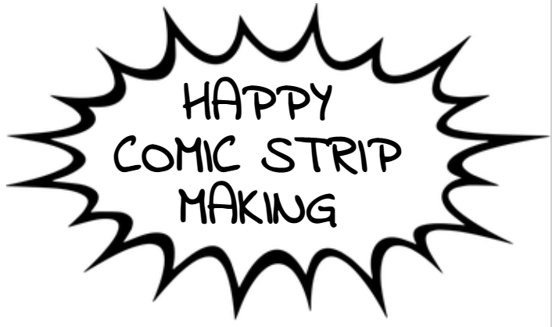

DAY 1 - Introduction to the Project

Get your students excited about comics! Read them one of your favorites, have a class conversation about all of their favorite comics, show lots of examples and pictures. The more excited the students are about this project, the greater the outcome will be!

Hook
Have a class discussion. Ask:
- Who reads comics?
- What are some of their favorite comics?
- What makes comics so interesting?

Let students know that they will be creating their own comic strips

Introduction
Explore Comic Strips - Show a variety of examples as a whole class.

Have a class discussion about the purpose of comic strips. Here are some questions that may help facilitate the discussion:
- Why do people read comic strips?
- What do you enjoy about comics?
- How are feelings conveyed in comics?
- How are books and comics the same? How are they different?

Body
Criteria: Hand out assignment sheet to students

A comic strip should have a theme and character(s). Similar to short-stories, comics must have a storyline. However, comics may be very short and they might not even have any words. The important thing is that the reader understands what is happening in the comic. Comics can be different lengths. Some have lots of characters, with big problems that they need to solve. Some have only one character and are short. It is up to you how detailed you want your comic to be.

Show students this video: https://www.youtube.com/watch?v=ufOXBuGhVWg&ab_channel=LEARN

Closure
Tomorrow you will be brainstorming what kind of characters you want in your comic strip.
DAY 2 - Brainstorming Character Development

Introduction
Have students start brainstorming their characters
- What are their characteristics going to be?
- What qualities do they have (leader, strong, fearless)?
- What are they going to look like?
- Do they have any special abilities or powers?
- Do they talk?
- Are they a person or an animal?

Students will have 5 minutes at the start of class to write down some ideas for their character. Then students will have time to get together with another person and talk about their characters.

Comic Strips
Today is when you can have examples of different comic strip layouts available for students to look at and use in their planning process. Students will be encouraged to not use a good copy of a sheet until their planning is complete.

Character References
Students can be given references to aid them in developing their protagonist and characters. Having a variety of styles and characters that students can look to for inspiration or even to trace can help students that are feeling hesitant due to their level of proficiency in art or that think “I can’t draw”.

DAY 3 - Planning Stage

Introduction
Students will have 5 minutes at the start of the class to look over their brainstorming from yesterday. They will set goals for what they want to accomplish this class period. Their goals might be to create their characters aesthetic, or brainstorm the setting/theme of their book.

After this 5 minute goal setting students will have 10 minutes to get together with someone in their neighborhood and bounce some ideas off of eachother.

After that 10 minutes students will head back to their desks to get as much of their planning done as possible.

Talk about goals/timeline for this class.

By the end of this class students should have:
- Created their character
- Decided on a setting/theme

Some students may be ready to start on their good copy today.

DAY 4 - Finishing up Planning / Starting Good Copy

Hook
Have students participate in a Think/Pair/Share activity based on the question:
What is something you appreciate about comic books that you don’t see in other media (like books or movies)?

This question will help them get started on the writing process for their comic strip

Work Period
Students will work on their own for the rest of the class period.

By the end of class all students should be wrapping up their “writing”

DAY 5 - Working on Good Copy

Introduction
Talk about goals/timeline for this class- looking towards the end of the week.

By the end of this class students should have:
- Begun “inking” their good copy.

Body
Individual work for this period.

DAY 6 - Work Period

Introduction
By the end of this class students should have:
- Finish “inking” their good copy.
- Started adding colour to their comic.

Body
Individual or partner work for this period.

DAY 7 - Work Period / Buddy Review

Introduction
This is the students last day to work on their comic strip. By the end of this class students should have:
- Completed all items on their Comic Check-List.

Body
Students will continue working to complete the good copy of their comic. Students will review their comic and go through the Check-List either independently or with a partner.

Closure
Go over the expectations for the Book Talk

DAY 8- Book Talk

Introduction
Review the expectations for the Book Talk.
- Students get into groups of 3-4
- Masks need to be worn at all times during the book talk
- The present shares their comic. The presenter may share what inspired them to create this, they may choose to read it to the group.
- The timekeeper will set the timer for two minutes
- When the presenter is sharing their comic, no one else should be talking
- When the presenter is done the audience may ask questions

